project

Courway website

**Team Members**

**Muhammad Ashraf Fathy Ahmed 2305181**

**Muhammad Elsyed Muhammad Ahmed 2305273**

**Yasser Ali Muhammad Muhammad 2305268**

**Mohamed Ahmed Fayek 2305298**

**Muhammad Hazem Hafez Mustafa 2305534**



***couerway***

**Project Overview:**

**"Courway" is an educational platform, designed to empower individuals to develop their skills through a variety of online courses. The platform aims to provide a premium learning experience combining quality, usability, and diversity.**

**Key Features:**

* **Instructor Dashboard:**
* **Enables instructors to easily create and manage courses.**
* **Tools to track student progress and engagement.**
* **Personalized Learning Experience:**
* **Course recommendations based on learners' interests.**
* **Options to track learning progress.**

**Target Audience:**

* **Learners: University students, working professionals, and individuals seeking skill development.**
* **Instructors: Experts and professionals interested in sharing knowledge and earning income through teaching.**

**Technical Implementation**

* **User Interface (UI): Simple and intuitive design for seamless navigation.**
* **Database: Using MySQL.**

**Login and Signup page**

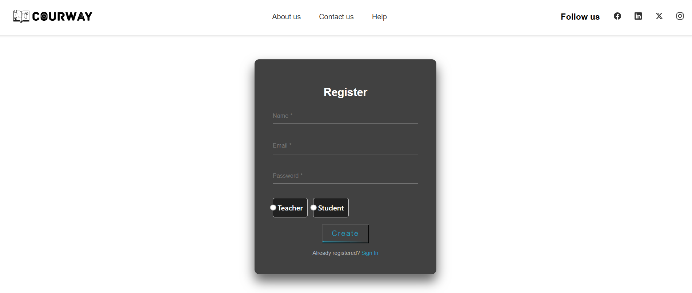

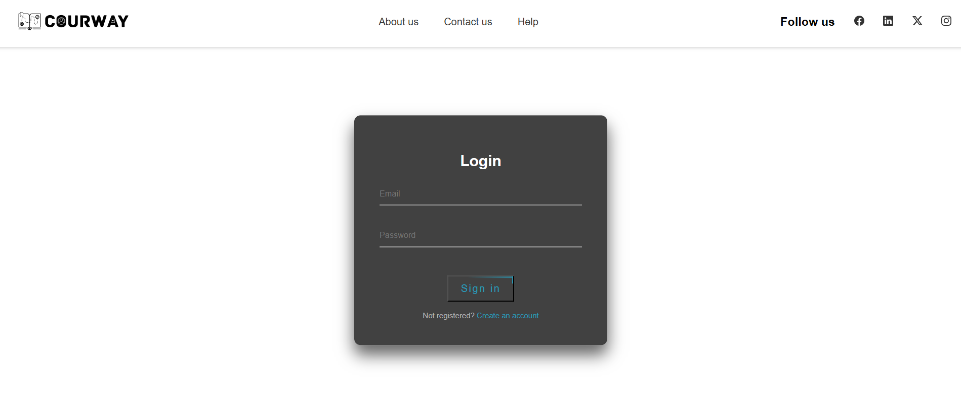

**Accounts**

**Instructor Account:**

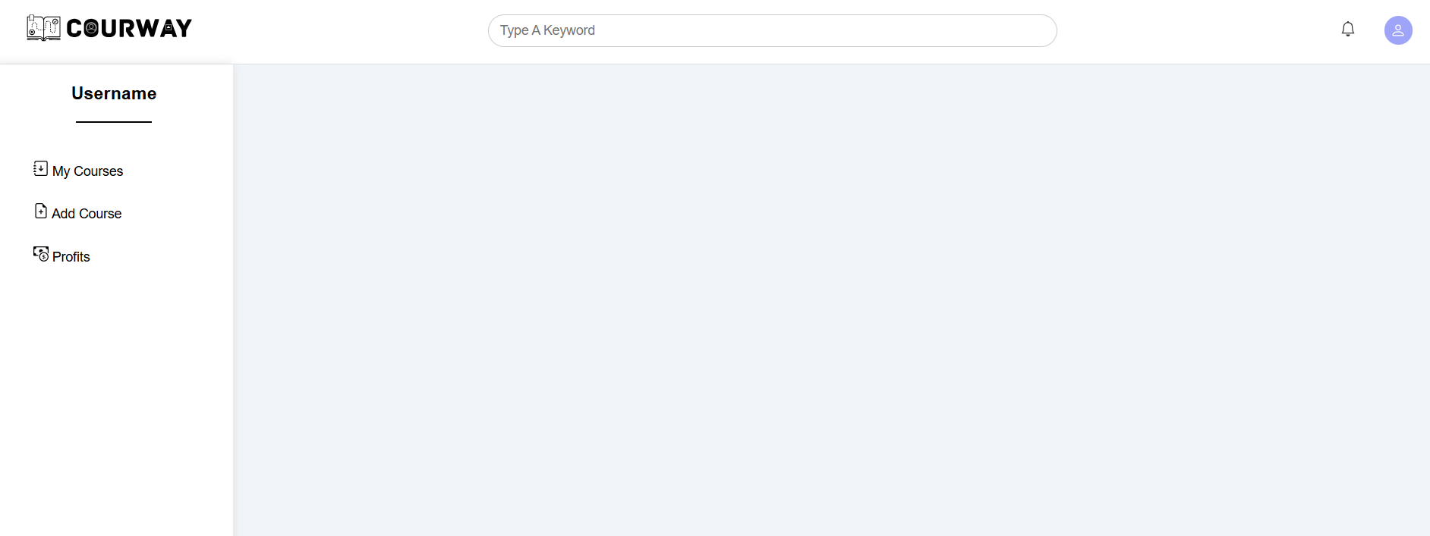

* **Upon creating an instructor account and logging in, the user is directed to a dedicated dashboard.**
* **The dashboard allows instructors to:**
  + **Add new courses.**
  + **Manage existing courses.**

**Student Account:**

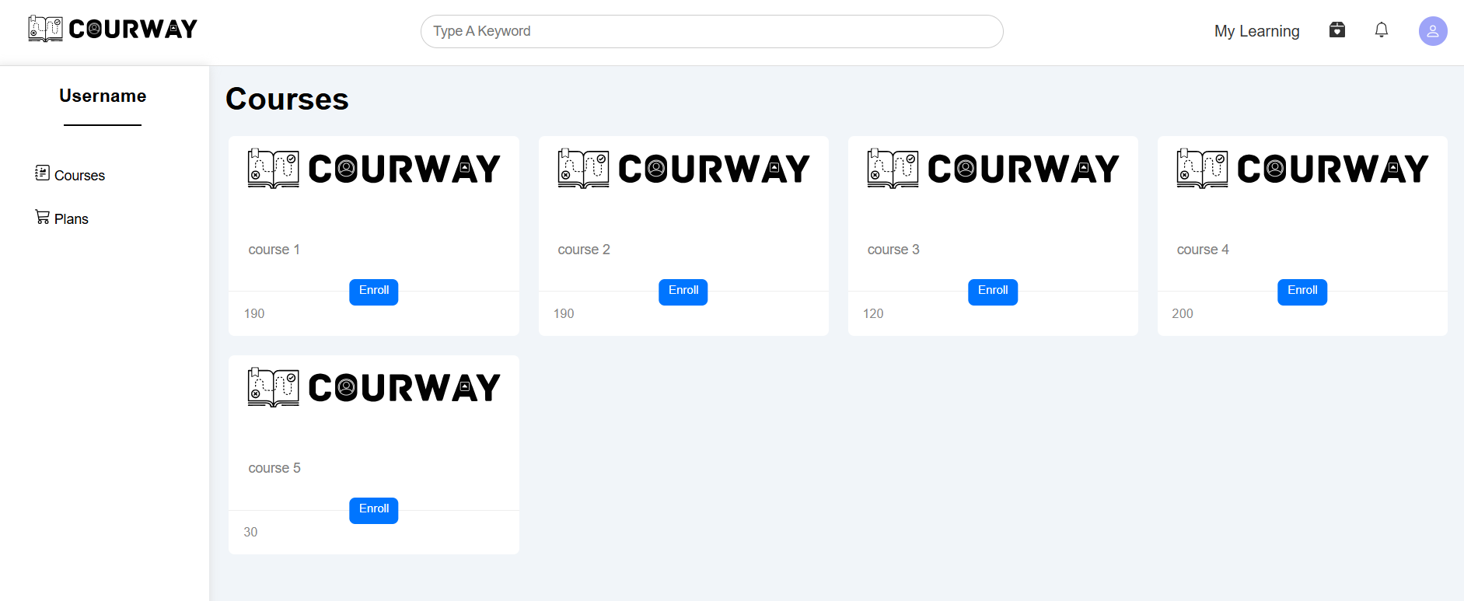

* **Upon creating a student account and logging in, the user is taken to a personalized homepage.**
* **The homepage allows students to:**
  + **Browse available courses.**
  + **Enroll in courses of interest.**
  + **Access their enrolled courses.**